Picnic spots near pokhara

# Dipang lake

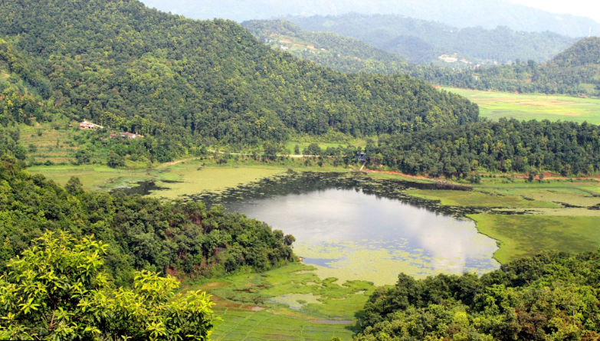

**LOCATION:**

Shishuwa-Aarupata-Archale Marga, Lekhnath 33700, Nepal

Coordinates:28.181028, 84.068922

Description: Among the other lakes in Pokhara, Dipang Lake is famous as a picnic spot. It lies nearly 10KM away from Pokhara. Peaceful environment along with the sight of lake amuse the people on the picnic.

# Karki danda

**LOCATION:**

Less than 5 KM away from Pokhara

Coordinates: 28.219920, 84.006979

# BANDIPUR

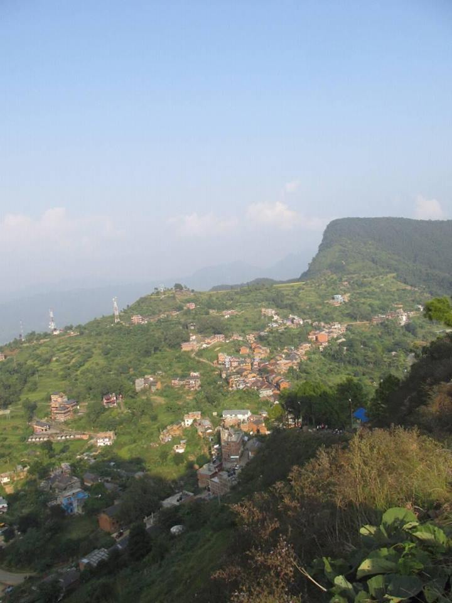

LOCATION:

27.921323, 84.406318

# HEMJA

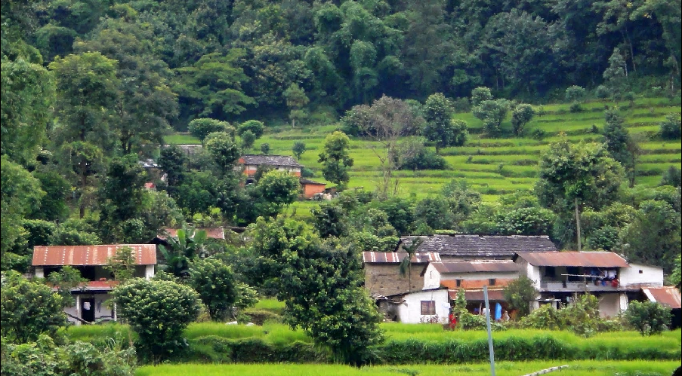coordinates 28.297545, 83.934425

Hemja lies in the northern part of Pokhara. It is also a major picnic destination for the people of Pokhara as well as others.

There are many spots around the plain land which provides the better picninc spots for the people .